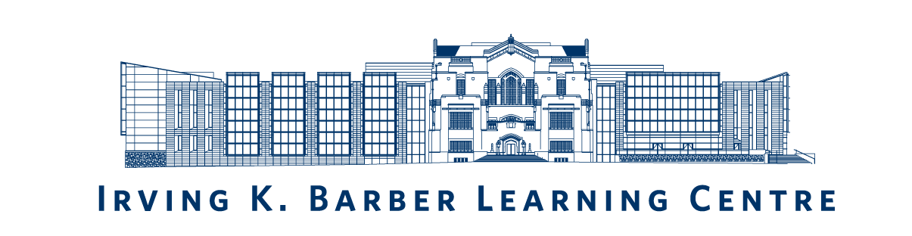
Please review the IKBLC Webcast Request proposal guidelines and requirements before completing this form.
Submit your completed proposal to Allan Cho, Community Engagement Librarian, allan.cho@ubc.ca. If you have questions or require assistance, you may contact him at 604.827.4366.
Description and Objectives Provide a description of the your event, including title of program, speaker bio, abstract, and indicate whether this is something new or existing. Describe how it meets the University’s strategic plan and how it meets the evaluation criteria. What are the objectives of your event? Provide a clear description of what you want to accomplish with this lecture recording.
Target Audience(s) (Select all that apply)
☐ Students  ☐ Faculty  ☐ Staff  ☐ Alumni |  | ☐ Development/Fundraising  ☐ Research Audience  ☐ Community (non-UBC affiliation)  ☐ Other (Please elaborate: Click here to enter text.)
Event Details Outline the details of the event requested for webcast recording, indicating timeline/ schedule, building/room information, audio/visual equipment, etc. that will be used during the program.

Budget Include a draft budget breakdown showing the expenses required for this production. [UBC IT Digital Media provides price list for on-campus services here]. Clearly indicate how much you are requesting from the Irving K. Barber Learning Centre webcast initiative and on which event you plan to use the funds. If applicable, identify in-kind sources of funding for equipment (such as livestream, multi-camera, off-campus, wireless mics, etc).
Other Information (Optional)
Name:
Title:
Unit/Organization:
Email:
Phone:
Signature of person submitting the proposal: |  |  | Date:
 | Upload e-signature or print document & sign.

