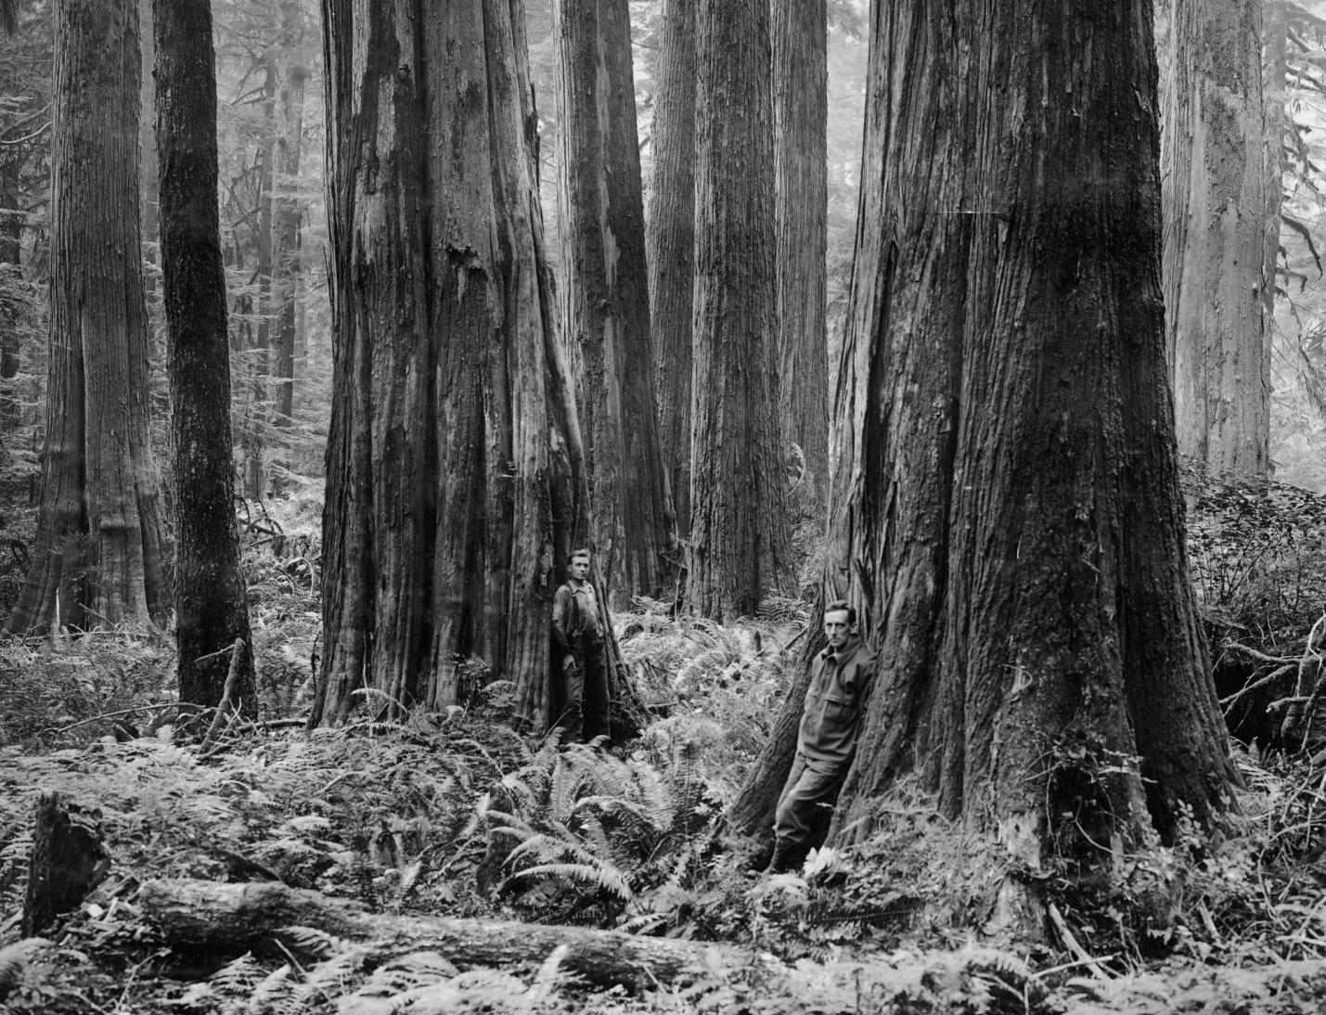

B.C. History Digitization Program
Application

Project summary
Applicant institution/organization:
Legal name of parent organization (if applicable):
Contact information for official correspondence: | Name, Title, Address, Telephone, Email
Project title:
Project start (YYYY/MM/DD): |  | Project end (YYYY/MM/DD):
Funding requested:
Contact information of project manager: | Name, Title, Address, Telephone, Email
Affirmation
- I affirm that the information in this application is accurate and complete and the project proposal, including activities and budgets, are fairly presented.
- I agree that if funding is provided, any deviation from expenditures included in the project proposal will require prior written approval of the Irving K. Barber Learning Centre.
- I certify that the materials to be digitized with Program funds are either in the public domain, or that all necessary copyright permissions to make the material available have been secured.
- I confirm that all digitized material created through this project will be fully and freely available on the web except in extenuating circumstances
- I agree to publicly acknowledge funding and assistance provided by the Irving K. Barber Learning Centre and to submit a final report on or before April 30, 2018 which includes a detailed financial accounting of the activities funded by the Learning Centre.
Authorized Signature: ___________________________________________________________
Name and Title (please print): _____________________________________________________
Date: _________________________________

Project Details (20 points)
Response
Describe the significance and impact of the proposed project.
Detail the resources your organization would dedicate to this project.
Provide a detailed project schedule for all activities.
Identify the role, responsibilities and/or project-related tasks of key participants, including contractors, consultants and staff

Digitization Details (20 points)
Response
Provide a short description of the material to be digitized and the anticipated output.
Detail how you have addressed any copyright concerns.
Explain how digitization best practices will be applied and describe formats and standards to be used.
Describe how quality control and testing will be incorporated.
Describe the equipment you or a third-party will be using for digitization?

Metadata and Description (20 Points)
Response
Have the materials to be digitized been described using a standard metadata scheme?
If yes to the above, tell us about it.
If no to the above, please outline your plan for description.

Access (20 points)
Response
Will you be using a digital asset management system (repository) to make the materials freely available online?
If yes to the above, tell us about it.
If no, please outline your plan for access.

Digital Preservation (10 points)
Response
Describe your digital preservation plan.

Promotion (10 points)
Response
Outline your plans for publicizing your digitized material.

Budget (Required)
Response
Provide a short description detailing the basis for calculating various expenditures (i.e. salaries and wages, equipment and software, services, project management, etc.)

Project Income
Provide a summary of the anticipated project income by entering the appropriate amount under the respective category. Applicant cash contribution must be a minimum of 25% of the Learning Centre Funds Requested.
Source of Income and Investment | Cash | In-kind | Total (Cash + In-kind)
Applicant | $ | $ | $
Learning Centre Funds Requested | $ |  | $
Other: (Specify) | $ | $ | $
Total Project Income | $ | $ | $

Project Costs/Expenses
Provide a summary of the anticipated project expenditures by entering the appropriate amount under the respective category. Further details to be entered in the Notes column.
Costs/Expenses | Notes | Cash | In-kind | Total (Cash + in-kind)
Salaries and Wages |  | $ | $ | $
Professional/Consultant Fees and Services |  | $ | $ | $
Travel and Meeting Costs |  | $ | $ | $
Marketing and Communications Costs |  | $ | $ | $
Equipment and Software Costs |  | $ | $ | $
Project Management (up to 5%) |  | $ | $ | $
Other Costs: (Specify) |  | $ | $ | $
Total Project Expenses |  | $ | $ | $

